Request for Redress

Name and Surname:
Application Reference:
Research Line/Position:

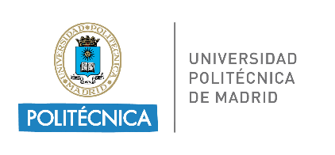

This project has received funding from the European Union’s Horizon 2020 research and innovation programme under the Marie Skłodowska-Curie grant agreement No. 945139

All applicants can make a request regarding procedural shortcomings, perceived incorrect application of eligibility criteria, or factual errors. Redress will not be possible regarding the scientific judgment of the Selection Committees and the interviewers.
To avail of the redress procedure, a request for redress must be submitted within 10 working days from the date of the publication of the results (Evaluation 1, Evaluation 2 and/or Evaluation 3).
Redress requests must be:
- Related to your individual Evaluation Summary Report (ESR), and/or position in the ranked list published.
- Completed using this form, including a clear description of the grounds for complaint.
- Submitted personally by the interested applicant.
- Sent by email in PDF format to sdgine@upm.es

No changes to the original application nor new documents completing the original application will be admitted. Request for Redress will be submitted to the Steering-Redress Committee of SDGine project.

ADMINISTRATIVE DATA
Name and Surname
E-mail
Application reference
Research line/Position

DETAILS OF GROUNDS FOR COMPLAINT
Please describe the grounds of your complaint regarding the Evaluation Summary Report (ESR) and/or the position in the ranked list published. Use a second page if necessary.

NAME

SIGNATURE AND DATE

As given by the Applicants’ Portal

