Declaration of Absence of Conflict of Interest

Name and Surname:
Research line(S)/Position(S):

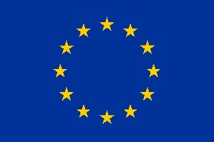

This project has received funding from the European Union’s Horizon 2020 research and innovation programme under the Marie Skłodowska-Curie grant agreement No. 945139

I, the undersigned, (full name), candidate to (research line(s)/position(s)) within SDGine project, confirm:
- That I understand that conflict of interest refers to situations in which financial or other personal considerations may interfere in the evaluation and selection process (e.g., affinity or consanguinity relationship with the supervisory team, economic interest with a third partner).
- I hereby declare that I do not have any conflict of interest that may arise from my application.
- Should any form of conflict of interest (possible or actual) which may inadvertently emerge during the conduct of my PhD thesis project, I will duly report it to the project coordinator for immediate action.

NAME

SIGNATURE AND DATE

